**Issue:** Change_Access_method_type_and_interconnect_type

**Resolution:**

1.Execute the below query and get the current Access_method_type_and_interconnect_type.

* select access_method_type,interconnect_type from logical_port where log_port_id=3732303

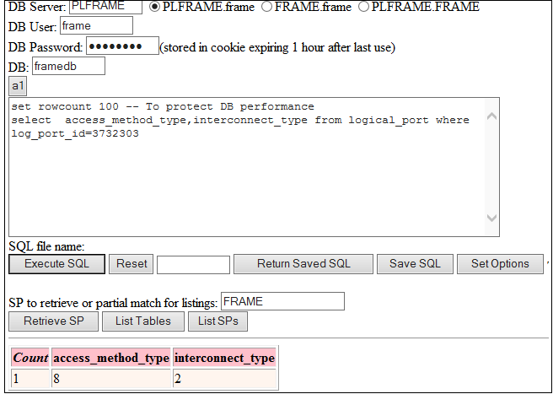

2.Based on the user request, update the Access_method_type_and_interconnect_type.

* update logical_port set access_method_type=8,interconnect_type=2 where log_port_id=3732303

**NOTE:** Please check Access_method_type_and_interconnect_type value as shown below

|  |  |  |  |  |
| --- | --- | --- | --- | --- |
| **Access Method Type Name** | **Type Value** |  | **Interconnect Name** | **Type Value** |
| Leased Line | 1 |  | Direct Connect | 1 |
| Intl Long Line | 2 |  | Provider GW Interconnect | 2 |
| Satellite | 3 |  | Provider Inter-AS | 3 |
| Ethernet | 4 |  |  |  |
| DSL | 5 |  |  |  |
| Zero Mile Access | 6 |  |  |  |
| ESP Ethernet Dedicated | 7 |  |  |  |
| ESP Ethernet Shared | 8 |  |  |  |
| ESP ATM Shared | 9 |  |  |  |
| Zero Mile Access Shared | 11 |  |  |  |
| Seamless Control Plane | 13 |  |  |  |

Reference Ticket : 227493329,223760375,224189698